7/17/2023

Project proposal for Ride Share Management System

|  |  |  |
| --- | --- | --- |
| Serial | Name | ID |
| 1. | Asif Sharif Akash | 20-42647-1 |
| 2. | Maharabur Rahman Apu | 20-42675-1 |
| 3. | Masud Pervez | 20-42656-1 |
| 4. | MD Shah Jalal | 20-43479-1 |

Group-4

**Software Project Proposal**

Pathao

Fahim Ahmed

House 613, 4th floor, Bijoy Sarani Begum Rokeya Sarani, Dhaka

17/07/2023

**Introduction**

Pathao is a Bangladeshi on-demand digital platform business with its corporate headquarters in Dhaka. The business has operations in Kathmandu and Chitwan in Nepal as well as Dhaka, Chittagong, Khulna, and Sylhet in Bangladesh. Pathao offers courier, meal delivery, ride-sharing, and online shopping services.

**Proposal for Ride Share Management System**

1. **Overview of the proposed system:**

A technology called ride sharing will enable single passengers to travel in groups with other people. Drivers and passengers will be the ones using the software the most in our system. Through their NID number, drivers and passengers can register and log in to the system. The administrator can log in and examine the driver's license, vehicle registration, and the availability of seats for the desired passengers. In order to customize the user experience, enhance safety, and give this application a competitive edge, it might enable riders to request the gender of the drivers. Therefore, creating this application can assist people/travelers in finding partners to share rides with at the lowest possible cost. There are many ride-sharing applications available right now. However, while requesting a ride, users are unable to specify the gender of their driver. Vehicle rides completely altered transportation with their rising popularity and public acceptability. This ride-request software has been a key contributor to the change to on-demand personal drivers, thus it will aid in growing the user base and optimizing market presence.

1. **Justifications:**

A single traveler can look for other people to ride along with. A tourist or passenger may choose the gender of their drivers. Drivers may be chosen based on their ratings. The administrator monitors the driver's license and vehicle licensing. A traveller can specify their destination and ask other passengers to share a trip. Depending on the amount of passengers, the tourists can even choose their own transportation or automobiles. The travelers can split the cost of the trip to a far-off location and pay separately. Payment options include credit card and cash. The choice is up to the driver whether to accept or reject the ride request. If a driver declines a ride in any way, the driver may mention the request to other drivers. A passenger or tourist may complain about the driver and rank the driver accordingly.

1. **Use case diagram of the proposed systems:**

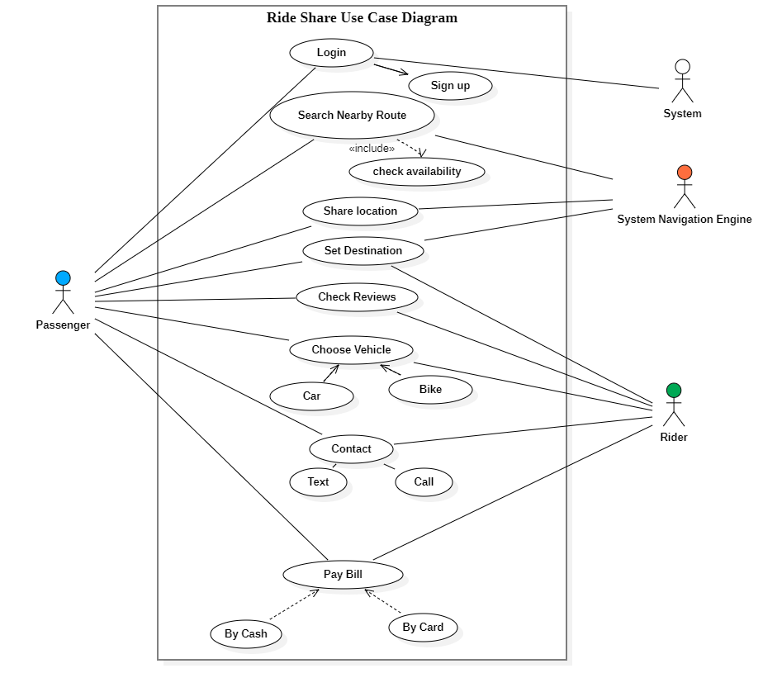

1. **Components, Scopes and feature:**

**Scope:**

The scope of this project is to provide rides to those who currently commute in cars. Because it can be shared with other passengers, it ensures to provide a comparable level of service but puts a larger emphasis on routes and destinations. It ensures that fewer resources and vehicles will be used for two or more services.

**Feature:**

1. Sign Up
2. Software Login
3. Set Destination
4. Book a Ride
5. Bide the Ride amount
6. Share the ride with other users
7. Ride information & Booking
8. Payment Mode
9. Rewards & Offer
10. Logout
11. **Objectives and sub-objectives:**

**Objective:** The objective is to develop a ride-sharing system for Pathao company.

**Sub-objectives:**

1. Create a log in system for the users
2. To develop a system for the ride management
3. To establish connection for the users
4. To develop passenger and driver log
5. To implement a GPS location system for the map and share location
6. To develop a payment and accountable system
7. Create a review and bonus reward section
8. **Primary and Secondary Stakeholders:**

**Primary Stakeholders:**

1. Passenger
2. Driver
3. Developers
4. QA Engineers
5. Database Engineer
6. Manager

**Secondary Stakeholders:**

1. Government
2. Consultant
3. Business Analyst
4. HR Personnel
5. **Technical Requirements:**
6. **Operating Systems:** iOS & Andriod.

**Specification:**

* Should be compatible with iPhone, iPad, and iPod touch. Application should be downloaded from iOS’s official App Store.
* Should be compatible with phones and tablets having Android 10 or later. Application should be downloaded from Google Play Store.

1. **Implementing Software Requirements:**

* **Requirement gathering Tools:** The system developer needs JIRA tools to perform managing, gathering, documenting the requirements for this software.
* **Prototyping tool:** These tools help in creating quick mockups and prototypes of the software to get feedback from stakeholders. Examples of such tools include Balsamiq, Axure, and Sketch.
* **Project management Tools:** The system developer needs smartsheet, Microsoft project to managing the overall project, including scheduling, resource allocation etc.
* **Testing tools:** The system developer needs selenium tools in perform testing activities before delivering the final product.

1. **Hardware Requirements:**

* Router
* Monitor
* Processor
* Cables
* Keyboard/Mouse
* Database Server
* LAN

**Timeline**

The project will take approximately [11-12 months], from the date of confirmation. The timeline and process steps are listed below:

**First Step:** week [1-4]

**Requirement analysis**

In-depth analysis of the requirement gathering for the project SRS Documentation.

**Second Step:** week [5-6]

**Design**

Create some design for the company to choose the best design for them.

**Third Step:** week [7-18]

**Development**

Software Coding is done.

**Fourth Step:** week [19-22]

**Implementation**

Here all the module of the project will be integrated and check whole system is working or not.

**Fifth Step:** week [23-26]

**Testing**

Activating the system and try to find the bugs and debug them as soon as possible.

**Sixth Step:** week [27-30]

**Training**

Staff training on how to run the software.

**Seventh Step:** week [31-34]

**Installation**

After completing all the training, testing session its ready for installation for the intended users.

**Eighth Step:** week [35-46]

**Support**

Checking for any bugs and errors; see if any fixing needs to be done.

**Payment Terms**

Upon signing the proposal, 30% [300000] of the total payment must be deposited.

**Pricing**

Our fee for the whole project from the first step to the last one will be $[10 lakh]. The breakdown is provided below:

|  |  |
| --- | --- |
| **SOFTWARE DEVELOPMENT** | **Taka [500000]** |
| **LAUNCH AND SUPPORT** | **Taka [300000]** |
| **TRAINING** | **Take [200000]** |

**Warranty & Limitation of Liability**

We provide a 90 days warranty, from the date of acceptance of our software proposal. During this time, if the software malfunctions, or doesn’t operate in any way, then we take the necessary steps to fix the issue and ensure that the Software operates according to the specifications. However, our services remain at your disposal for any future assistances.

**Contact us:**

You can contact us with any of the following ways:

Phone: 01960424642

E-mail: asifakash@gmail.com

Fax: 212-656-2233

Website: [http://www.xyzsoftwaresolutions.com/](http://www.XYZsoftwaresolutions.com)

We look forward to hearing from you.

Regards,

Ride Share Management System